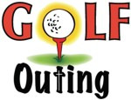

**You’re invited to….**

**MFDA’s**

**2018 Golf Outing**

#### Join us for MFDA’s 2018 Golf Outing at beautiful Northville Hills Golf Club, an Arnold Palmer Signature Course, on June 20th.

**The cost is $125 per golfer and includes 18-holes of golf, cart, lunch and a reception following the golf outing sponsored by the Michigan Funeral Supply Sales Association.**

**Hole Sponsorships are available for $500 per hole, which includes a sign.**

**Where: Northville Hills Golf Club When: June 20, 2018 Time: 9:00 a.m. Registration**

**15565 Bay Hill Dr. 10:00 a.m. Shot Gun start**

**Northville, MI 48168**

**GOLF REGISTRATION**

If you are putting together a team, one person from your team should send in the entry amount **WITH** names of golfers listed on registration form. If you are not a part of a team, MFDA will choose your teammates.

# of Golfers _____x $125=________

**PAIRINGS:**

1.____________________________________________

2.____________________________________________

3.____________________________________________  
4. ___________________________________________

**REGISTRATION DEADLINE JUNE 15, 2018**

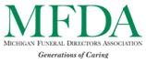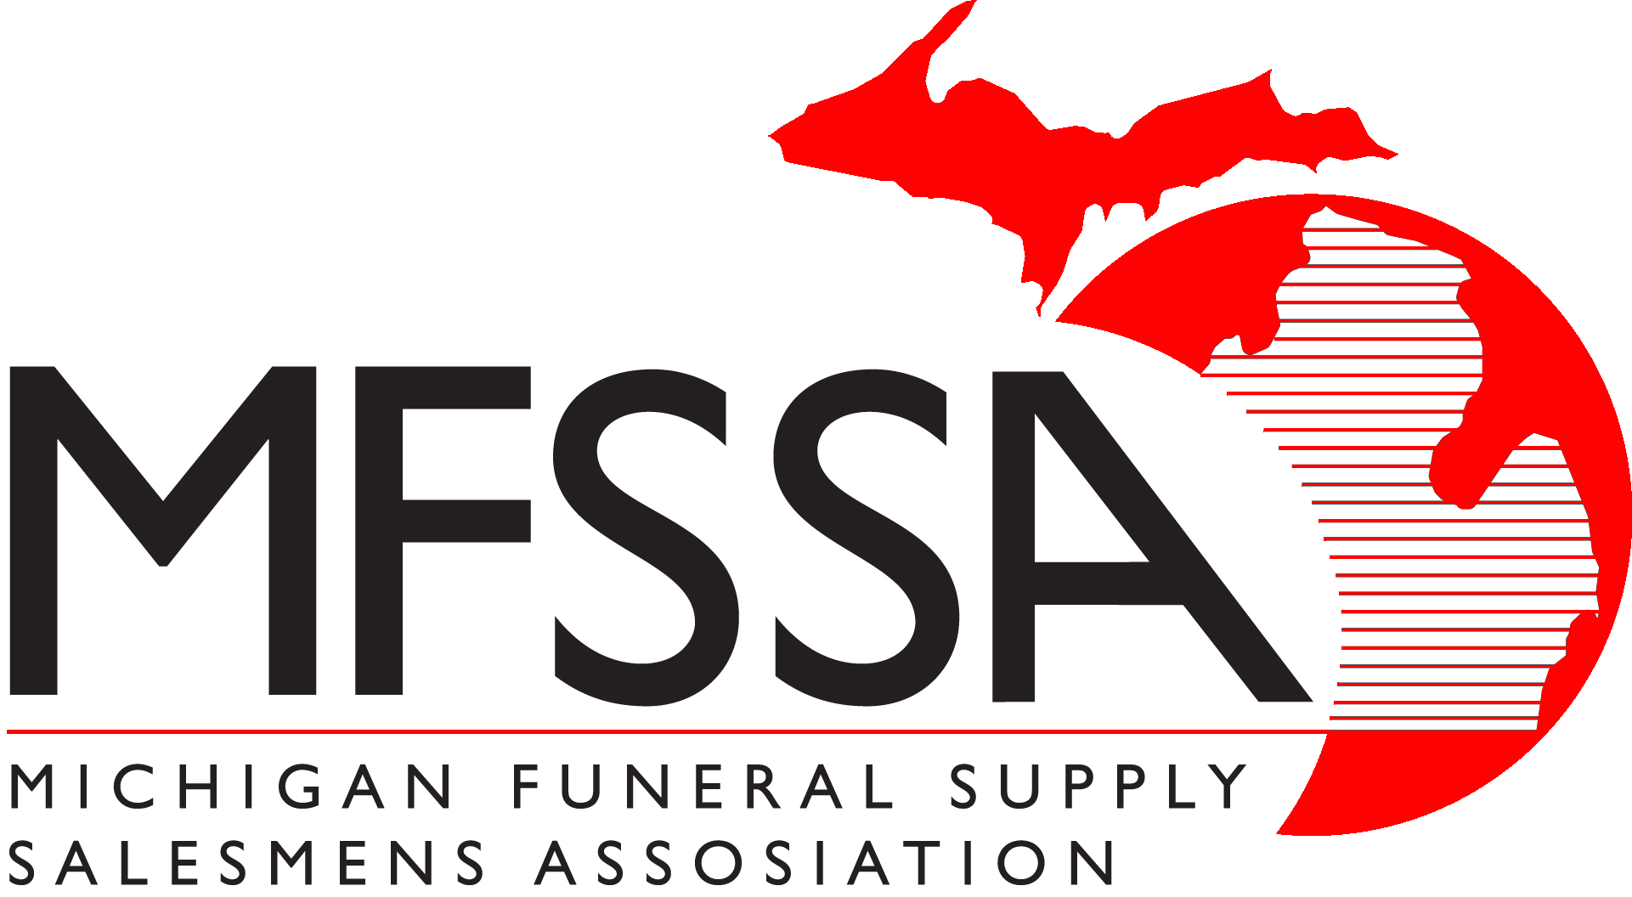

**PAYMENT INFORMATION**

**[ ]** Payment by Check  
**[ ]** Payment by Credit Card  
 Visa Master Card Amex

Name on Card:

Card Number:

Exp. Date: Sec. Code:

Signature:   
Email:

**SPONSORSHIPS**

Hole Sponsorships are available for $500 per hole, which will include a sign.

# of hole sponsorships x $500=________

Company Name: _______________________________

Contact Person: ________________________________

Phone Number: ________________________________

Email: _______________________________________

**SPONSORSHIP DEADLINE JUNE 13, 2018**