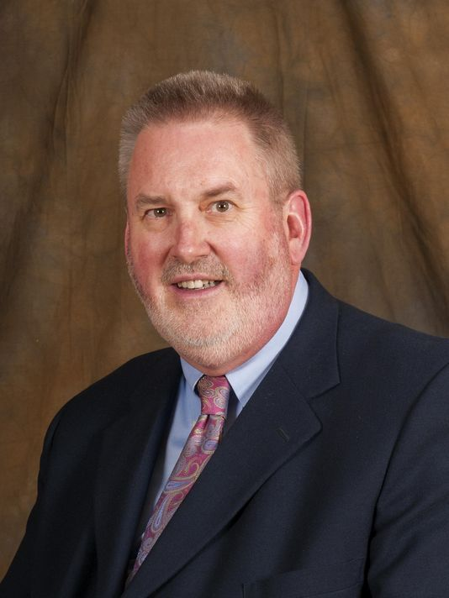

Wagner: Protect your loved ones, select the right funeral home
Eugene Wagner is president of the Michigan Funeral Directors Association. He is the owner of Wagner Family Funerals in Cassopolis and Three Oaks, MI.
Last week, a flurry of media coverage focused on the Swanson Funeral Home of Flint, MI – recently shut down due to alleged violations and complaints regarding health, safety and financial matters.
There were reports of vile and unsanitary conditions resulting in the Michigan Department of Licensing and Regulatory Affairs (LARA) suspending the licenses to practice of both the funeral home and the funeral director, O’Neil Swanson II.
The State was 100% correct in taking action, and those of us in the funeral profession are sickened by what happened. The relationship between a grieving family and their funeral director is a sacred bond of trust. We applaud the State for responding strongly when that bond is broken.
This case is not normal, by any means. Still, it is important for consumers to be aware of the funeral home they choose and its reputation.
Follow these tips to aide in your search for a funeral professional:
1) Check to see if the funeral director is a member of the Michigan Funeral Directors Association (MFDA). You can visit the MFDA’s searchable online database (MFDA.org) or call and ask our association staff for a recommendation (1.888.955.6332). The Swanson Funeral Home in Flint was not a member.
The best advice for those looking for funeral services is to trust professionals – someone you are comfortable with and in whom you can place your confidence. All of the members of MFDA are licensed, reputable funeral directors located throughout the state of Michigan.
All licensed funeral homes are also searchable via a tool on the Michigan Department of Licensing and Regulatory Affairs website as well. Here you can find verified information on both individual funeral directors and funeral homes, as well as information on license sanctions.
2) Always be ready to ask questions and get information.
Funeral professionals are ready and willing to offer information and guidance. We understand that you are coping with a stressful and life changing event. That is why we welcome your questions and want to help you find the most important and meaningful ways of honoring the life of someone very special.
3) What’s important to you is important to us.
A few examples of things to consider that may help put you at ease are as follows:
- Check to see if the funeral home is a member of MFDA, whose members ascribe to a code of ethics.
- Know who you are dealing with, who owns the firm and how long have they been in funeral service.
- Ask for options and explanations. Many times families are not aware of the options available to them. Take the time you need to think before making any final decisions. Clarify any additional costs and fees up front as well and ask about any financial assistance should it be necessary.
- Make sure you receive a general price list of all of the funeral director’s offerings of service and goods.
- If you are feeling pressured or hurried, slow down. A good funeral director wants you to be confident in your choices and comfortable with your decisions.

4) Trust your gut.
If something about the home, service or staff just seems off to you, trust your gut. Even if you cannot pinpoint something specific that just may not feel right, it is best to go to someone that you and your family are 100% comfortable with. Instances of subpar sanitary conditions and ethics violations are not common and are not to be tolerated.
Funeral directors are trusted by all of us during some of the most difficult periods of our lives. They should work as your friend and advocate, helping you and your family as you manage the final affairs of someone you love very much.
Transparency, integrity and honesty are just a few of the supports a funeral director should give you and your family during a time of ultimate need. As a consumer, it’s important to ensure that you choose a licensed funeral home that upholds all of these standards.
The Michigan Funeral Directors Association and the family firms that make up its membership strive to ensure that all families are provided the best care and support.
Eugene Wagner is president of the Michigan Funeral Directors Association. He is the owner of Wagner Family Funerals in Cassopolis and Three Oaks, MI.
MFDA is the nation’s oldest organization of funeral professionals, currently representing roughly 1200 funeral directors serving 500 funeral homes statewide. The MFDA mission is to enhance the value of funeral service and the profession through government advocacy, public information and professional

